Unit-1

Types of Databases and Database Applications

Basic Definitions

Database: A collection of related data.

Data: Known facts that can be recorded and have an implicit meaning.

Database Management System (DBMS): A software package/ system to facilitate the creation and maintenance of a computerized database.

Database System: The DBMS software together with the data itself. Sometimes, the applications are also included.

Main Characteristics of the Database Approach

Self-describing nature of a database system: A DBMS catalog stores the description of the database. The description is called meta-data). This allows the DBMS software to work with different databases.

Insulation between programs and data: Called program-data independence. Allows changing data storage structures and operations without having to change the DBMS access programs.

Data Abstraction: A data model is used to hide storage details and present the users with a conceptual view of the database.

Support of multiple views of the data: Each user may see a different view of the database, which describes only the data of interest to that user.

Sharing of data and multiuser transaction processing : allowing a set of concurrent users to retrieve and to update the database. Concurrency control within the DBMS guarantees that each transaction is correctly executed or completely aborted. OLTP (Online Transaction Processing) is a major part of database applications.

Advantages of Using the Database Approach

Controlling redundancy in data storage and in development and maintenence efforts.

Sharing of data among multiple users.

Restricting unauthorized access to data.

Providing persistent storage for program Objects

Providing Storage Structures for efficient Query Processing

Providing backup and recovery services.

Providing multiple interfaces to different classes of users.

Representing complex relationships among data.

Enforcing integrity constraints on the database.

Drawing Inferences and Actions using rules

Potential for enforcing standards: this is very crucial for the success of database applications in large organizations Standards refer to data item names, display formats, screens, report structures, meta-data (description of data) etc.

Reduced application development time: incremental time to add each new application is reduced.

Flexibility to change data structures: database structure may evolve as new requirements are defined.

Availability of up-to-date information – very important for on-line transaction systems such as airline, hotel, car reservations.

Economies of scale: by consolidating data and applications across departments wasteful overlap of resources and personnel can be avoided.

Historical Development of Database Technology

Early Database Applications: The Hierarchical and Network Models were introduced in mid 1960’s and dominated during the seventies. A bulk of the worldwide database processing still occurs using these models.

Relational Model based Systems: The model that was originally introduced in 1970 was heavily researched and experimented with in IBM and the universities. Relational DBMS Products emerged in the 1980’s.

Object-oriented applications: OODBMSs were introduced in late 1980’s and early 1990’s to cater to the need of complex data processing in CAD and other applications. Their use has not taken off much.

Data on the Web and E-commerce Applications: Web contains data in HTML (Hypertext markup language) with links among pages. This has given rise to a new set of applications and E-commerce is using new standards like XML (eXtended Markup Language).

History of Data Models

Relational Model: proposed in 1970 by E.F. Codd (IBM), first commercial system in 1981-82. Now in several commercial products (DB2, ORACLE, SQL Server, SYBASE, INFORMIX).

Network Model: the first one to be implemented by Honeywell in 1964-65 (IDS System). Adopted heavily due to the support by CODASYL (CODASYL - DBTG report of 1971). Later implemented in a large variety of systems - IDMS (Cullinet - now CA), DMS 1100 (Unisys), IMAGE (H.P.), VAX -DBMS (Digital Equipment Corp.).

Hierarchical Data Model: implemented in a joint effort by IBM and North American Rockwell around 1965. Resulted in the IMS family of systems. The most popular model. Other system based on this model: System 2k (SAS inc.)

Object-oriented Data Model(s): several models have been proposed for implementing in a database system. One set comprises models of persistent O-O Programming Languages such as C++ (e.g., in OBJECTSTORE or VERSANT), and Smalltalk (e.g., in GEMSTONE). Additionally, systems like O_{2,} ORION (at MCC - then ITASCA), IRIS (at H.P.- used in Open OODB).

Object-Relational Models: Most Recent Trend. Started with Informix Universal Server. Exemplified in the latest versions of Oracle-10i, DB2, and SQL Server etc. systems.

Navigational and procedural nature of processing

Database contains a complex array of pointers that thread through a set of records.
Little scope for automated "query optimization”

When not to use a DBMS

When a DBMS may be unnecessary:

If the database and applications are simple, well defined, and not expected to change.

If there are stringent real-time requirements that may not be met because of DBMS overhead.

If access to data by multiple users is not required.

Database System Concepts and Architecture

Data Models

Data Model: A set of concepts to describe the structure of a database, and certain constraints that the database should obey.

Categories of data models

Conceptual (high-level, semantic) data models: Provide concepts that are close to the way many users perceive data. (Also called entity-based or object-based data models.)

Physical (low-level, internal) data models: Provide concepts that describe details of how data is stored in the computer.

Implementation (representational) data models: Provide concepts that fall between the above two, balancing user views with some computer storage details.

Schemas versus Instances

Database Schema: The description of a database. Includes descriptions of the database structure and the constraints that should hold on the database.

Database Instance: The actual data stored in a database at a particular moment in time. Also called database state (or occurrence).

Database Schema Vs. Database State

Database State: Refers to the content of a database at a moment in time.

Initial Database State: Refers to the database when it is loaded

Valid State: A state that satisfies the structure and constraints of the database.

Schema is also called intension, whereas state is called extension.

Three-Schema Architecture

Proposed to support DBMS characteristics of:

Program-data independence.

Support of multiple views of the data.

Defines DBMS schemas at three levels:

Internal schema at the internal level to describe physical storage structures and access paths. Typically uses a physical data model.

Conceptual schema at the conceptual level to describe the structure and constraints for the whole database for a community of users. Uses a conceptual or an implementation data model.

External or view level schemas at the external level to describe the various user views. Usually uses the same data model as the conceptual level.
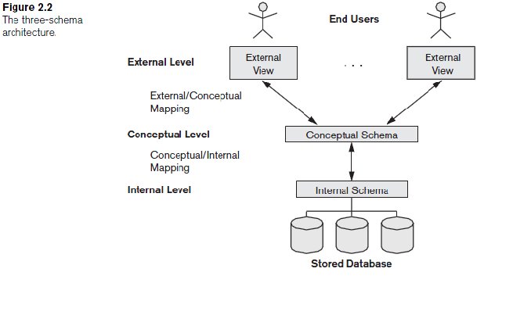

Data Independence

Logical Data Independence: The capacity to change the conceptual schema without having to change the external schemas and their application programs.

Physical Data Independence: The capacity to change the internal schema without having to change the conceptual schema.

When a schema at a lower level is changed, only the mappings between this schema and higher-level schemas need to be changed in a DBMS that fully supports data independence. The higher-level schemas themselves are unchanged. Hence, the application programs need not be changed since they refer to the external schemas.

Centralized and Client-Server Architectures

Centralized DBMS: combines everything into single system including- DBMS software, hardware, application programs and user interface processing software.

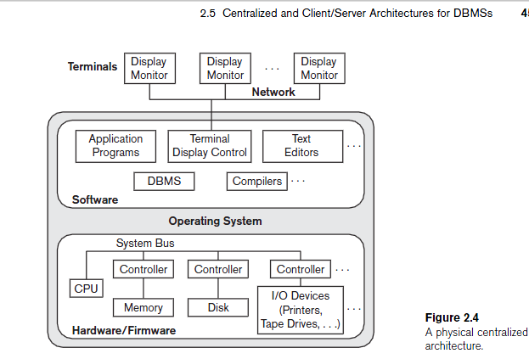

Basic Client-Server Architectures

Specialized Servers with Specialized functions

Clients

DBMS Server
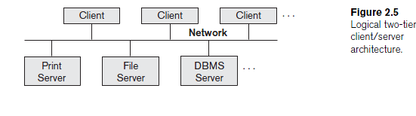

File Servers

Printer Servers

Web Servers

E-mail Servers

Clients:

Provide appropriate interfaces and a client-version of the system to access and utilize the server resources.

Clients maybe diskless machines or PCs or Workstations with disks with only the client software installed.

Connected to the servers via some form of a network.
(LAN: local area network, wireless network, etc.)

DBMS Server

Provides database query and transaction services to the clients

Sometimes called query and transaction servers

Two Tier Client-Server Architecture
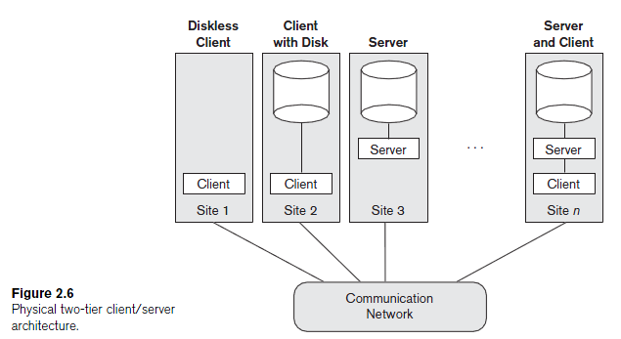

User Interface Programs and Application Programs run on the client side

Interface called ODBC (Open Database Connectivity – see Ch 9) provides an Application program interface (API) allow client side programs to call the DBMS. Most DBMS vendors provide ODBC drivers.

A client program may connect to several DBMSs.

Other variations of clients are possible: e.g., in some DBMSs, more functionality is transferred to clients including data dictionary functions, optimization and recovery across multiple servers, etc. In such situations the server may be called the Data Server.

Three Tier Client-Server Architecture

Common for Web applications

Intermediate Layer called Application Server or Web Server:

stores the web connectivity software and the rules and business logic (constraints) part of the application used to access the right amount of data from the database server

acts like a conduit for sending partially processed data between the database server and the client.
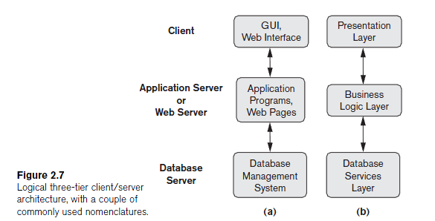

Classification of DBMSs

Based on the data model used:

Traditional: Relational, Network, Hierarchical.

Emerging: Object-oriented, Object-relational.

Other classifications:

Single-user (typically used with micro- computers) vs. multi-user (most DBMSs).

Centralized (uses a single computer with one database) vs. distributed (uses multiple computers, multiple databases)

